

md

Aim:
To set up and access the Azure DevOps environment by creating an organization through the Azure portal.

INSTALLATION:
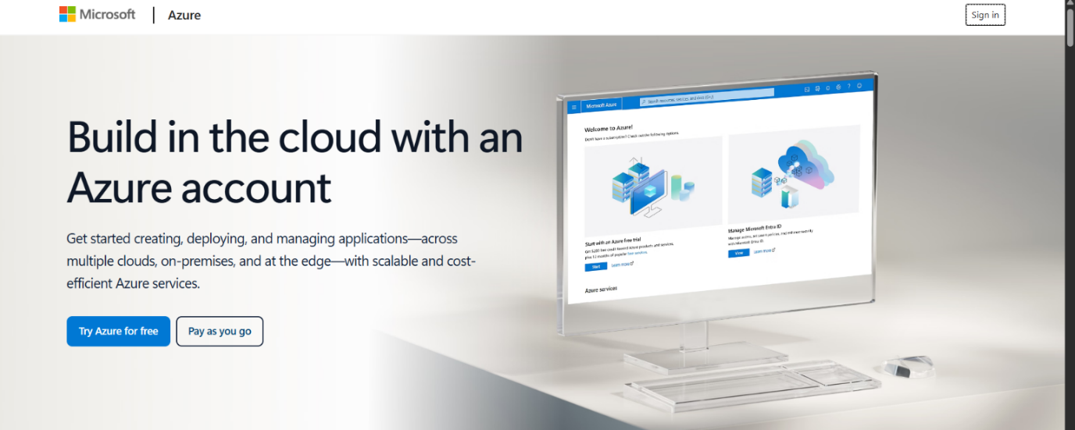
AZURE HOME PAGE
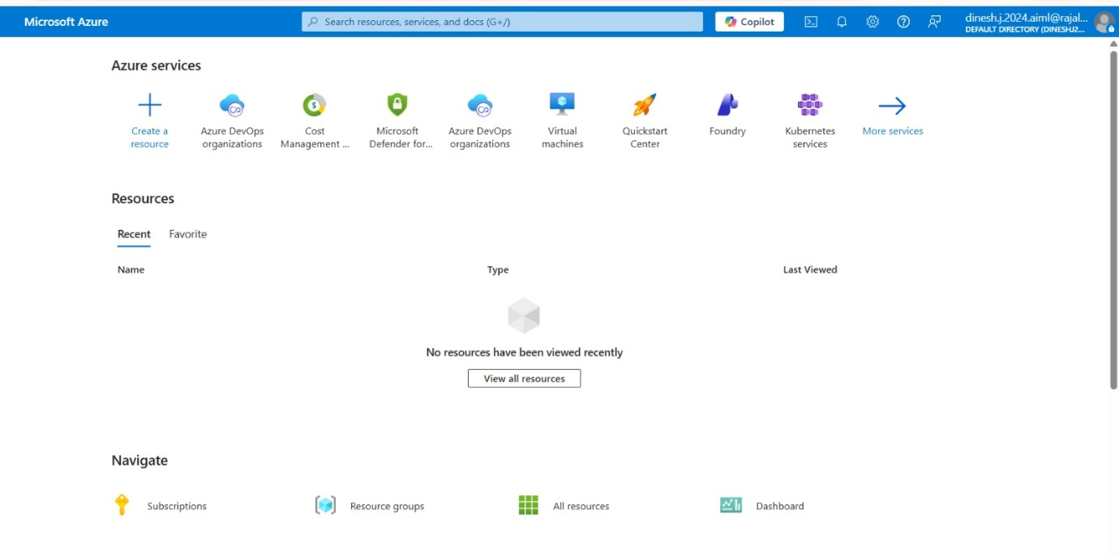

AZURE DEVOPS
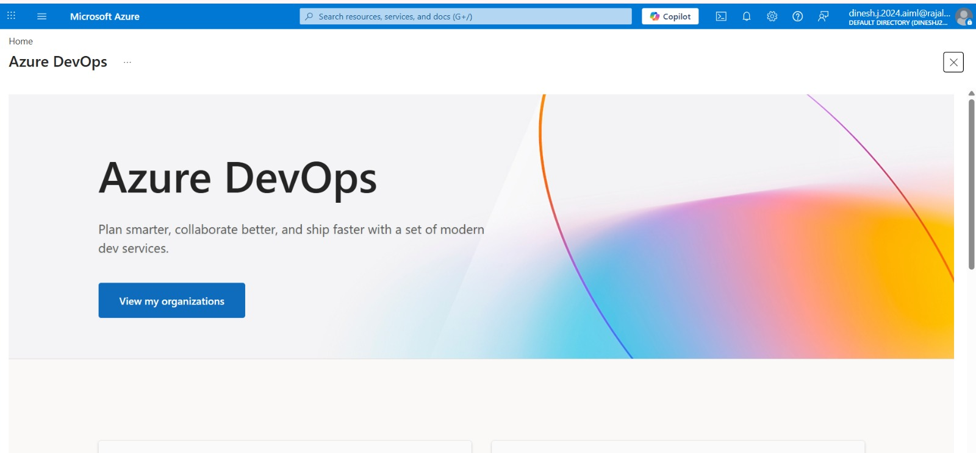

Result:
Successfully accessed the Azure DevOps environment and created a new organization through the Azure portal.

